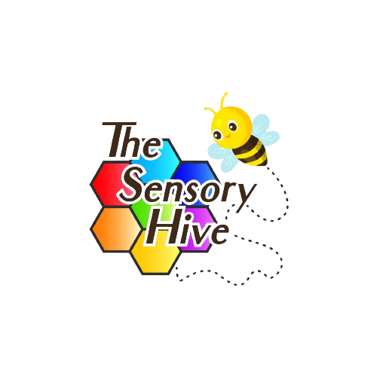

The Sensory Hive LTD
Children’s Privacy Notice

Date: 29/03/24 | The Sensory Hive LTD | Address: Weyman Avenue, L35 2YW
Review Date:  29/03/25 | Ref: The Sensory Hive Children’s Privacy Notice | Assessor:  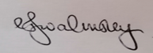  Lyndsey Walmsley
Amended on: | New Ref/Version: | Signed:
Amended on: | New Ref/Version: | Signed:
Amended on: | New Ref/Version: | Signed:

Protecting Your Data
What is a privacy notice?
A privacy notice helps you understand how we use information about you, like your name, address, date of birth and all the notes we have recorded whenever you come to see us. It also tells you how we make sure your information is kept safe
Why do we need one?
The United Kingdom General Data Protection Regulation (UK-GDPR) and the Data Protection Act 2018 are active laws that make sure that your information is looked after. Everybody must follow these laws including The Sensory Hive. We must make sure that your information is kept safe.

What is UK-GDPR?
UK-GDPR is a document that helps The Sensory Hive keep information about you secure. This law makes sure that all staff at the centre follow the rules and keep your information safe.
What we do?
We are here to provide a service to you. In order to do this, the centre keeps information about you such as your name, address, your birthday, telephone numbers, the reason you are coming to see us, the name of the person who will generally bring you to your appointments/sessions and the reason that you are coming to see us, any information you or your family gives us and any other information to enable us to care for you.
Why do we collect information?

Our main purpose at The Sensory Hive is to deliver quality care to adults and children. We collect the information we need to care for you in the best way. We ask for your address so that we know where we can contact you, we ask for your date of birth as your age may be important to your care and each time you come to see us we will write down things that you tell us, things that we tell you and advice/information we give you so that way we can look back at what we have done for you to make sure we are treating you in the best way.
What do we do with it and how do we keep it safe?
We keep the information we collect electronically and on paper. All of this information together is in your file and anyone involved in caring for you at the Centre can see what has been collected. This way we can all make the right decisions about your care with all of the information you have given us.
Everyone working in our Centre understands that they need to keep your information safe; this is called keeping your information confidential or protecting your privacy. Staff are only allowed to look at your information if they are involved in your care or to help us run our Centre and they understand that they must keep any information safe especially the information that identifies you. This might be your name or address and anything you come to see us about. We are not allowed to give any of this type of information to anyone who shouldn’t see it. This includes talking to them about it.

Who do we share it with?
We may share the information we record about you with others involved in your care. We routinely share information with school nurses, but not directly with school unless it is important for them to know. We might need to share this information with medical teams, such as hospitals.
Your parents/guardians should get a copy of any letters we send about your care. Some of you may decide that you do not want information being shared with your parents/guardians, we would advise you to speak to a member of our team if you have any questions about this.
If you have a social worker, we will share it with them too. That way they are kept up to date on what we are doing for you.
We may have to share information with the police, the courts and other organisations and people who may have a legal right to see your information.
If you tell us something that makes us worried about your safety or the safety of someone else you know, we might have to share this with other people outside of the centre - even if you don’t want us to. This is part of our job to keep you and others safe.
Sometimes we might be asked to take part in research that might help you in the future. We will always ask you or your parent(s) or adult with parental responsibility if we can share your information if this happens.
Don’t want to share?
All our clients, no matter what their age, can say that they do not want to share their information. If you have any concerns about this please speak to a member of the team
How long do we keep your information for?
We will keep a copy of your information for as long as you are registered with us. We will ensure that a copy of any information we hold about you is passed on so you can continue with your care. We have to follow the Records Management Code of practice 2021 which is a document that tells them how long they have to keep records for. Once the records have been kept for the time needed they will be safely deleted/ destroyed.
What are your rights over your personal data?
You have the following rights over your data we hold:
- You or your parent/guardian (if they have parental responsibility or you have agreed) can ask for a copy of any data the practice holds about you. We will need to know what you/they want to see - it may just be part of your record, or a report. We will check they are who they say they are to make sure we are not sharing your information with anyone who shouldn’t see it.

- You or your parent/guardian (if they have parental responsibility or you have agreed) can ask us to fix your record if they notice something is incorrect, out of date or if information is missing.

- If we have asked for your permission to share your information for example for medical research and you or your parent/guardian said yes, if you then decide you don’t want to share anymore you can withdraw your consent.

- If you think there are any errors in the information we hold about you then you can ask us to correct it but the law says we can’t remove any of the information we hold about you even if you ask us to. This is because we need this information to take care of you.

- If you would like to talk to us about not sharing your information, even if this means you don’t want us to share your information with your parent(s) or adult with parental responsibility, please let us know. We will be happy to help.
To ask for a copy of to the information we have about you or to let us know if your information isn’t right please speak with a member of our staff.
What if I have a question?
A member of our staff/receptionist will be happy to talk to you about any questions you may have and we will do our best to help you.
The Sensory Hive has a person called a Data Protection Officer (DPO) who deals with all queries about patient information. One of our team may put you in touch with this person who will listen to your concerns and give you the advice you need.
Our DPO is Hayley Peden and can be contacted at hayley@thesensoryhive.co.uk
What if I have a complaint about how you look after my information?
We will always do our best to look after your information and to answer questions you might have.
You can call the centre or discuss on a visit or you can contact us using the following information:
Email us at: admin@thesensoryhive.co.uk
Or write to us at: The Sensory Hive, Weyman Avenue, Whiston, Liverpool, L35 2YW
If you are still not happy with something we have done with your information you can speak to our DPO.
If our DPO has not been able to help you or if you prefer not to speak to our DPO then you have a right to pass your complaint to an organisation called the Information Commissioner’s Office (ICO) who will look into what has gone wrong.
You can contact them by calling 0303 123 1133 or go online to www.ico.org.uk/concerns

